Organization profile for Consider Child First (CCFUganda)
Name of the organisation | Consider Child First (CCFUganda)
Date of establishment | March - 2017
Legality (registration) | Registered with Uganda Registration Services Bureau (URSB), Nakalama Sub county, Iganga local government as Community Based Organization (CBO) , Busoga Sub region Joint civil Society Organization (BSJCO)).
Contact address | Postal: P.O Box 413  Iganga –Uganda  Physical: Iganga – Nampirika *A*,  Bukaye parish  Nakalama sub county  Uganda  Tel: +256789359469 / +256704806537  E –mail: childuganda22@gmail.com  Kisalamaa22@gmail.com  Web site: www.ccfuganda.org  Facebook page: Ccfuganda
Contact person | Kisalama Aggrey Abraham  Tel: +256789359469  Email:kisalamaa22@gmail.com
Vision | “To invoke caring , self-reliant and productive citizens”.S
Mission | “To give vulnerable children and young people the protection and practical help they urgently need, and tirelessly campaign for lasting change ”
Shared value | “Every Child and Youth is my Brother / Sister”.
Objectives | - To create social stability and awareness on reproductive issues, HIV / AIDS and other related adolescence issues.  - Creating avenue for advocacy for human rights, peaceful resolution of conflicts and sustain socio- economic development among the marginalized communities.  - To advocate for a society whereby children and youth with disabilities have equal rights and opportunities for growth and development.  - Improved access to education and psycho-social well being of marginalized children and youth.  - Increase household income through self help projects hence eradicating household poverty among the victims of armed conflict and marginalized communities.  - Unconditional release of the children and youth by the Lord’s Resistance Army
Activities of the organisation | Life skills development, we support children to promote their talents i.e we use Brassbound music to make them realize their potential, self-discovery, esteem, confidence. Also we engage children in tailoring skills, hair dressing and traditional culture dance purposely for culture diversity, storytelling, sports, Dance and drama, playing games awareness campaign as part of psychosocial.  In education, We provide scholastic materials like books pencil, pen mathematic sets, school uniforms and school fees /tuition  Child protection  Formation and training of child protection committees, community dialogue meetings, and support to community led initiatives on child protection, translation of key legal and policy documents into local languages, data collection on violation of children’s rights and supporting formal education for Orphans and Vulnerable Children in the community  Livelihoods Support  Nutrition and livelihood development, provide food to children fot both the residential and nonresidential.  legal justice, we support children to find justice through probation offices and the office of family and child protection unit from police who later submits cases to family courts for prosecutions.  Reproductive Health  This is done through: Behavioral Change Communication (BCC), awareness and sensitization, guidance and counseling, distribution of Information Education and Communication materials, HIV/AIDS Counseling and Testing and community outreaches.

CCFUganda.  Organogram | 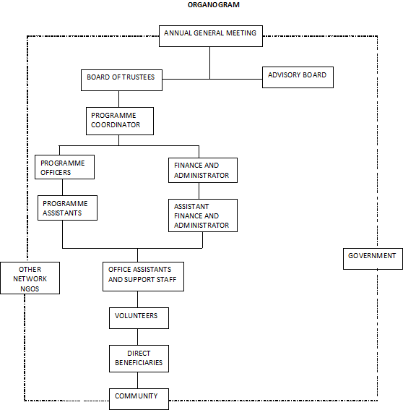  LIAISON OFFICER  HEAD OF SKILLS DEPARTMENT  CHILD PROTECTION OFFICER  CHIEF EXECUTIVE OFFICER  BOARD OF DIRCTORS

